Experiment worksheet

8.1 There are different ways of reproducing

Pages 140–141 and 211

Experiment 8.1: Vegetative propagation

Aim

To produce a new plant using vegetative propagation.

Materials

• 2 x 500 mL beakers

• Distilled water

• Scissors

• Geranium plant

• Flowerpots with potting mix

Method

1 Fill the beakers 3/4 full with distilled water.

2 Use the scissors to cut four healthy stems with 1–2 healthy leaves on each from the same plant.

3 Place the cut ends of the stems into the distilled water.

4 Observe the cut ends of the stems for 2–3 weeks.

5 Transfer the cuttings to the flowerpots.

6 Water the plants regularly and observe their growth.

Results

Record your observations in the space provided. Take photos of any changes in growth.

|  |
| --- |
|  |

Discussion

1 Is this form of reproduction sexual or asexual? Provide a reason for your answer.

2 How similar is the genetic material in the parent plant to that of the new (daughter) plants?

3 Will the daughter plants be identical in shape and size to the parent plant?

4 A student claimed that they were making plant clones. What are plant clones? Was the student correct?

Conclusion

What do you know about vegetative propagation?

Experiment worksheet

8.4 Things sometimes go wrong in reproduction

Pages 146–147 and 211

Challenge 8.4: Working with the RSPCA

The RSPCA is a community-based charity, famous across Australia for its work with and for animals.Unlike humans, animals do not have a voice and so they cannot ask for help. The RSPCA is one of the best ‘voices’ for animals and their rights. One of the RSPCA’s biggest campaigns is about desexing, mostly to do with cats. Every year, approximately 60 000 cats are brought in to the RSPCA; of these, over half have to be put down.

What to do

Create a mathematical model (or diagram) demonstrating how many cats can be produced from two fertile cats.

This task is exponential, meaning that when the two cats reach 6 months of age they can start to breed and, after 60 days, will have a litter of four kittens, after 6 months these four kittens will also be able to have kittens themselves and so on. Cats can start the breeding cycle almost straight after having kittens, which means, on average, cats can have three litters of kittens a year.

Include a graph that shows the growth of numbers of cats against time in the space below.

|  |
| --- |
|  |

Discussion

1 Explain what desexing is and why it is important.

2 Based on your calculations, how many cats were produced after 4 years?

3 How would desexing the first mating pair change your results?

4 Do you think this was a ‘fair test’? Explain the reasons for your answer.

5 What other factors could affect the number of cats?

6 Why do you think the RSPCA takes in so many more cats than dogs?

Experiment worksheet

8.5 Plant sexual reproduction produces seeds

Pages 148–149 and 212

Experiment 8.5: Flower dissection

Aim

To examine the main parts of a flower.

Materials

• Newspaper

• A flower (you can dissect any type of flower available; lilies and fuchsias are a good choice)

• Scalpel blade or sharp knife

• Hand lens

Method

1 Place the newspaper on the bench.

2 Cut the flower off the stalk.

3 Observe the flower. Identify the main parts of the flower from Figure 1.

4 Draw a labelled diagram of the flower.

5 Gently remove the sepals and petals.

6 Look for the stamens with anthers at the top. The anthers hold the pollen. You should be able to dust some pollen onto your finger.

7 Cut off the male parts at the bottom of the petal.

8 Observe the female part of the flower. It has the stigma at the top and the ovary at the bottom.

9 Cut the ovary lengthwise. In it you will see tiny white scales, which are the ovules. When the ova inside the ovules are fertilised by the pollen, they will grow to become seeds and the ovary will grow to become the fruit.

10 Draw a labelled diagram of the ovary.

11 Clean up your bench by wrapping the flower in the newspaper. Wash your hands.

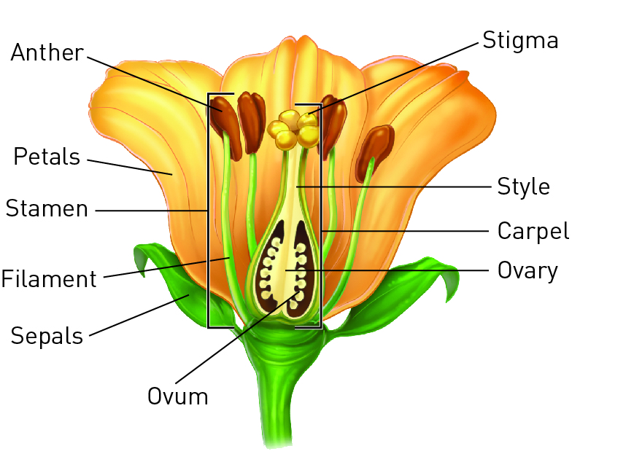

Figure 1 The structure of a flower

Results

Draw labelled diagrams of the male and female parts of the flower.

|  |
| --- |
|  |

Discussion

1 What colour is the filament (the stem of the stamen)? Why do you think this is?

2 How easy was it to clean the pollen from your fingers? Is this good for the flower?

3 How were the male and female parts arranged to encourage pollination? Explain.

4 Do you think the flower is more likely to be self-pollinated or cross-pollinated? Explain.

5 Do you think pollination is more likely to be by wind, water or animals? Explain.

Conclusion

What do you know about the parts of a flower? Exploring physical changes